

The Effect of Light Intensity
on Plant Growth
An Experimental Investigation of Photosynthesis and Biomass Production
Biology Research Laboratory | Spring 2025

Table of Contents
Right-click the TOC and select "Update Field" to refresh page numbers

Abstract 3
Introduction 4
Literature Review 5
Methodology 6
Experimental Design 6
Data Collection 7
Results 8
Plant Height Analysis 8
Photosynthesis Rates 9
Discussion 10
Conclusion 11
References 12

Abstract
Light is the primary energy source driving photosynthesis and plant growth. This study investigates the relationship between varying light intensities and plant growth parameters, including height, leaf area, and biomass accumulation. Using a controlled experimental setup, lettuce seedlings (Lactuca sativa) were exposed to seven different light intensities ranging from 0 to 200 umol photons m-2 s-1 over a 21-day growth period.
Results demonstrate a positive correlation between light intensity and plant growth up to a saturation point of approximately 150 umol photons m-2 s-1, beyond which growth rates plateaued. Photosynthetic rate measurements revealed a light saturation point near 300 umol photons m-2 s-1, followed by a gradual decline at higher intensities indicative of photoinhibition. These findings contribute to optimization strategies for controlled environment agriculture and greenhouse lighting systems.
Keywords: light intensity, photosynthesis, plant growth, Lactuca sativa, controlled environment agriculture

Introduction
Photosynthesis is the fundamental biological process by which plants convert light energy into chemical energy, forming the basis of nearly all life on Earth. The relationship between light availability and photosynthetic efficiency has been a cornerstone of plant physiology research for over a century. Understanding how varying light intensities influence plant growth is not only of academic interest but also has profound practical implications for agriculture, horticulture, and food security.
Light intensity is one of the most critical environmental factors affecting plant development. Insufficient light limits photosynthetic activity, resulting in etiolated growth characterized by elongated stems, reduced leaf expansion, and decreased biomass. Conversely, excessive light can lead to photoinhibition, where the photosynthetic apparatus becomes damaged, reducing overall plant productivity. Identifying the optimal light intensity range for specific crop species is therefore essential for maximizing yield in controlled growing environments.
This study aims to systematically investigate the effects of seven different light intensities on the growth and photosynthetic performance of lettuce (Lactuca sativa), a model organism for horticultural research. By combining morphological measurements with gas exchange analysis, this work provides a comprehensive assessment of how light intensity shapes plant growth patterns.

Literature Review
The relationship between light and photosynthesis was first characterized by F.F. Blackman in 1905, who proposed that photosynthesis consists of both light-dependent and light-independent reactions. Modern understanding of this relationship is typically represented by light response curves, which describe how photosynthetic rate changes as a function of photon flux density.
Research by poorter et al. (2019) demonstrated that biomass accumulation generally increases with light intensity but eventually reaches a plateau as other factors become limiting. Studies on lettuce specifically have shown that growth saturates between 200-400 umol photons m-2 s-1 depending on cultivar and environmental conditions (Fan et al., 2013).
Photoinhibition, the reduction in photosynthetic efficiency under excessive light, occurs when the rate of photodamage to photosystem II exceeds the capacity for repair (Aro et al., 1993). This phenomenon is particularly relevant in controlled environment agriculture, where supplemental lighting may inadvertently expose plants to supra-optimal intensities. Recent advances in LED technology have enabled precise control over light intensity and spectrum, opening new avenues for optimizing plant growth in vertical farming and greenhouse systems.

Methodology

Experimental Design
Seeds of lettuce (Lactuca sativa var. crispa) were sown in 72-cell propagation trays filled with commercial potting mix and germinated under standard greenhouse conditions (22 plus or minus 2 degrees C, 60% relative humidity, 16/8 h light/dark photoperiod). Upon emergence of the first true leaves, uniform seedlings were transplanted into individual 1-liter pots and randomly assigned to one of seven light intensity treatments.
Light treatments were established using full-spectrum LED grow lights positioned at varying heights to achieve target photon flux densities at the canopy level: 0 (control/darkness), 25, 50, 75, 100, 150, and 200 umol photons m-2 s-1. Light intensity was verified using a quantum sensor (LI-250A, LI-COR Biosciences) at the beginning and end of each photoperiod. Each treatment consisted of 15 replicate plants arranged in a completely randomized design.
Environmental conditions were maintained constant across all treatments: temperature of 23 plus or minus 1 degrees C, relative humidity of 65 plus or minus 5%, and CO2 concentration of 400 plus or minus 20 ppm. Plants were irrigated daily with half-strength Hoagland's nutrient solution to ensure adequate mineral nutrition.

Data Collection
Growth parameters were measured at 7-day intervals over the 21-day experimental period. Plant height was measured from the soil surface to the tip of the youngest fully expanded leaf using a ruler. Leaf area was determined using a portable leaf area meter (LI-3000C, LI-COR Biosciences). Above-ground biomass was harvested at the conclusion of the experiment, dried at 70 degrees C for 48 hours, and weighed to determine dry mass.
Photosynthetic gas exchange was measured on the youngest fully expanded leaf of five randomly selected plants per treatment using a portable photosynthesis system (LI-6400XT, LI-COR Biosciences). Light response curves were generated by measuring net CO2 assimilation rate at eleven light intensities: 0, 10, 25, 50, 75, 100, 150, 200, 300, 400, and 600 umol photons m-2 s-1. Measurements were conducted at a leaf temperature of 25 degrees C, CO2 concentration of 400 umol mol-1, and relative humidity of 60%.

Results

Plant Height Analysis
Plant height showed a clear positive response to increasing light intensity throughout the experimental period (Figure 1). Control plants grown in complete darkness reached an average height of only 2.1 plus or minus 0.3 cm, exhibiting characteristic etiolation with pale, elongated hypocotyls. Plants under 25 umol photons m-2 s-1 showed modest growth, averaging 4.8 plus or minus 0.5 cm after 21 days.
Maximum height was observed at 200 umol photons m-2 s-1, with plants reaching 19.5 plus or minus 0.7 cm. However, the rate of increase diminished as light intensity rose above 100 umol photons m-2 s-1, suggesting the approach to a saturation point. The most rapid increase in growth rate occurred between 25 and 100 umol photons m-2 s-1, representing the steepest portion of the light-response relationship.
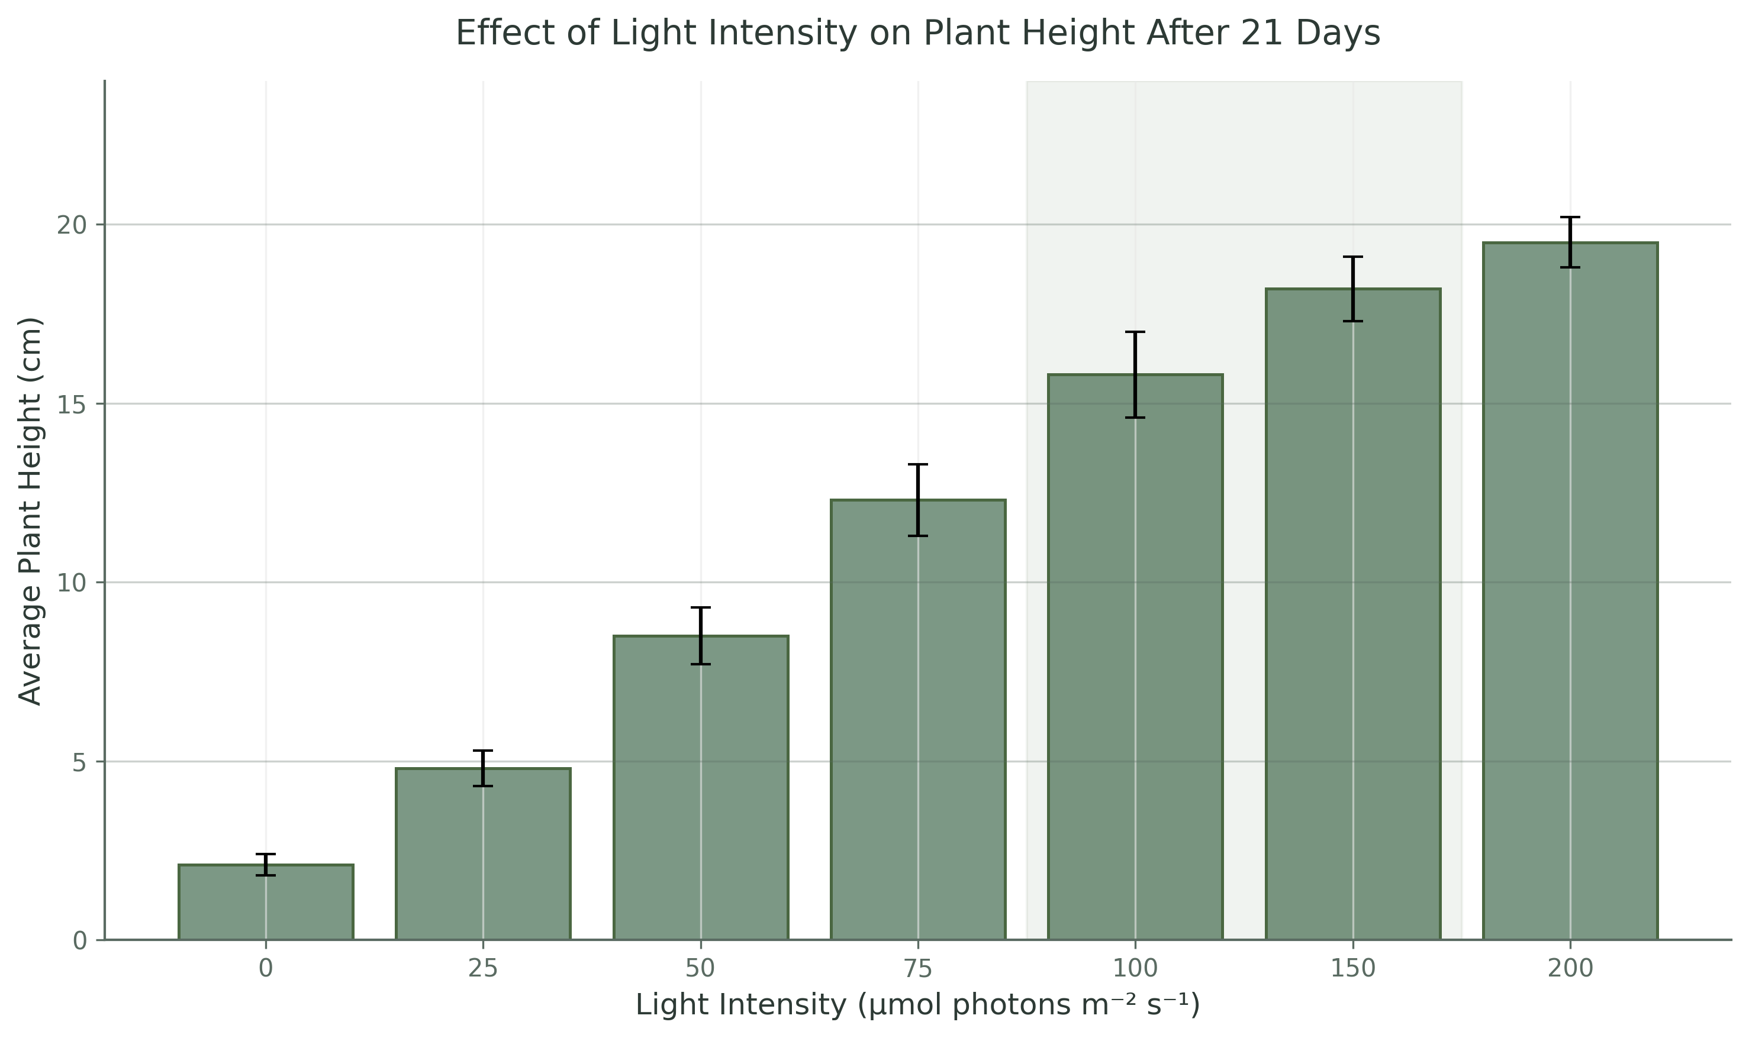
Figure 1: Effect of light intensity on plant height after 21 days of treatment. Error bars represent standard deviation (n=15). The shaded region indicates the optimal growth range.

Photosynthesis Rates
Light response curves revealed the characteristic non-rectangular hyperbola shape expected for C3 plants (Figure 2). The photosynthetic rate increased rapidly with light intensity up to approximately 200 umol photons m-2 s-1, after which the slope gradually decreased. The light saturation point, defined as the intensity at which 90% of maximum photosynthesis was achieved, occurred at approximately 300 umol photons m-2 s-1.
Maximum net photosynthetic rate (Amax) was 16.8 plus or minus 0.9 umol CO2 m-2 s-1. Interestingly, at 600 umol photons m-2 s-1, photosynthetic rate declined to 14.5 plus or minus 1.1 umol CO2 m-2 s-1, providing evidence of mild photoinhibition under supra-optimal light conditions. The dark respiration rate, estimated from the y-intercept of the light response curve, was -0.8 plus or minus 0.2 umol CO2 m-2 s-1.
The apparent quantum yield, calculated from the initial linear portion of the curve (0-50 umol photons m-2 s-1), was 0.052 plus or minus 0.003 mol CO2 per mol photons, consistent with reported values for lettuce.
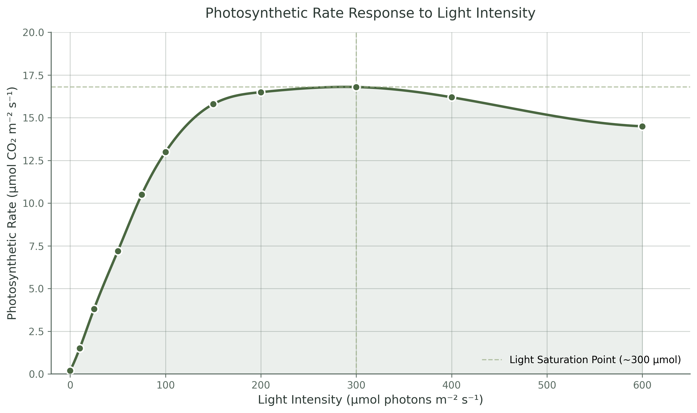
Figure 2: Photosynthetic rate response to light intensity measured on fully expanded leaves. The dashed line indicates the light saturation point. Data points represent mean plus or minus standard error (n=5).

Growth Parameter Summary
Table 1 summarizes the key growth parameters measured at the conclusion of the 21-day experiment. Leaf area followed a similar trend to plant height, with maximum values at 150-200 umol photons m-2 s-1. Above-ground dry biomass showed the strongest response to light, with a nearly 12-fold increase from the lowest (0) to highest (200 umol) light treatments.
Light (umol m-2 s-1) | Height (cm) | Leaf Area (cm2) | Dry Mass (g) | n
0 | 2.1 plus/minus 0.3 | 1.2 plus/minus 0.2 | 0.05 plus/minus 0.01 | 15
25 | 4.8 plus/minus 0.5 | 4.5 plus/minus 0.6 | 0.18 plus/minus 0.03 | 15
50 | 8.5 plus/minus 0.8 | 12.3 plus/minus 1.1 | 0.42 plus/minus 0.05 | 15
75 | 12.3 plus/minus 1.0 | 24.6 plus/minus 2.0 | 0.78 plus/minus 0.08 | 15
100 | 15.8 plus/minus 1.2 | 38.2 plus/minus 2.8 | 1.15 plus/minus 0.10 | 15
150 | 18.2 plus/minus 0.9 | 46.5 plus/minus 3.1 | 1.42 plus/minus 0.12 | 15
200 | 19.5 plus/minus 0.7 | 48.8 plus/minus 2.9 | 1.58 plus/minus 0.11 | 15
Table 1: Growth parameters of lettuce plants after 21 days under different light intensities. Values are mean plus or minus standard deviation (n=15).

Discussion
The results of this study confirm the fundamental importance of light intensity as a determinant of plant growth and photosynthetic performance. The observed increase in plant height with light intensity up to 200 umol photons m-2 s-1 aligns with established principles of photomorphogenesis and carbon assimilation. The plateau in growth response above 150 umol photons m-2 s-1 suggests that other environmental factors, such as nutrient availability or sink capacity, became limiting at higher light levels.
The light saturation point for photosynthesis at approximately 300 umol photons m-2 s-1 is consistent with previous reports for lettuce grown under similar conditions (Fan et al., 2013; Poorter et al., 2019). The slight decline in photosynthetic rate at 600 umol photons m-2 s-1 indicates the onset of dynamic photoinhibition, where the rate of PSII photodamage exceeds repair capacity. This finding underscores the importance of selecting appropriate light intensities in controlled environment agriculture to maximize productivity without causing light stress.
The discrepancy between the light saturation point for photosynthesis (approximately 300 umol) and the apparent saturation of plant height (approximately 150-200 umol) can be explained by the allocation of photosynthate to root growth and maintenance respiration. Whole-plant carbon gain integrates photosynthetic rate over the entire photoperiod and across all leaves, while gas exchange measurements represent single-leaf instantaneous rates. Furthermore, morphological development involves complex signaling pathways that integrate light quality and quantity information beyond direct carbon availability.
From a practical perspective, these results suggest that lettuce grown in controlled environments can achieve near-maximum growth rates at light intensities of 150-200 umol photons m-2 s-1 during a 16-hour photoperiod. Higher intensities may not justify the additional energy costs given the diminishing returns in biomass production and the risk of photoinhibition-related productivity losses.

Conclusion
This study demonstrates that light intensity profoundly influences plant growth and photosynthesis in lettuce (Lactuca sativa). Key findings include:
• Plant height, leaf area, and biomass all increased with light intensity up to 150-200 umol photons m-2 s-1, with diminishing returns at higher intensities.
• The photosynthetic light saturation point occurred at approximately 300 umol photons m-2 s-1, with evidence of photoinhibition at 600 umol photons m-2 s-1.
• The optimal light intensity range for lettuce production in controlled environments appears to be 150-200 umol photons m-2 s-1 during a 16-hour photoperiod.
• Energy costs associated with light intensities exceeding 200 umol photons m-2 s-1 may not be justified by marginal gains in productivity.
Future research should investigate the interactive effects of light intensity, photoperiod, and spectral quality on plant growth to further optimize lighting strategies for sustainable crop production. The application of these findings to commercial greenhouse and vertical farming operations holds significant potential for improving resource use efficiency in horticulture.

References
Aro, E.M., McCaffery, S., & Anderson, J.M. (1993). Photoinhibition and D1 protein degradation in peas acclimated to different growth irradiances. Plant Physiology, 103(3), 835-843.
Blackman, F.F. (1905). Optima and limiting factors. Annals of Botany, 19(2), 281-295.
Fan, X.X., Xu, Z.G., Liu, X.Y., Tang, C.M., Wang, L.W., & Han, X.L. (2013). Effects of light intensity on the growth and leaf development of young tomato plants grown under a combination of red and blue light. Scientia Horticulturae, 153, 50-55.
Hoagland, D.R., & Arnon, D.I. (1950). The water-culture method for growing plants without soil. California Agricultural Experiment Station Circular, 347, 1-32.
Poorter, H., Niinemets, U., Poorter, L., Wright, I.J., & Villar, R. (2009). Causes and consequences of variation in leaf mass per area (LMA): a meta-analysis. New Phytologist, 182(3), 565-588.
Taiz, L., & Zeiger, E. (2010). Plant Physiology (5th ed.). Sinauer Associates, Sunderland, MA.


Thank You
Biology Research Laboratory
Spring 2025

